Web Service

SOAP : we can consume data only in xml format

Rest Full Web Service : we can consume data in any format like xml or json or any other format.

Micro Service : small service

Login module customer module manager module feedback module etc

Product module Order module account module login module etc

Combine these module in one project and we have create the war file and deploy in production environment.

Product Module deploy independently can be develop using different language running on different server with different database it can be sql or no sql database.

Order Module deploy independently

Account Module deploy independently

Login Module deploy independently

Those module be created using same technologies and different technologies running on same server or different server can be database may be same or different.

Those independent module running on same server or different server they can interact with each other using REST API call.

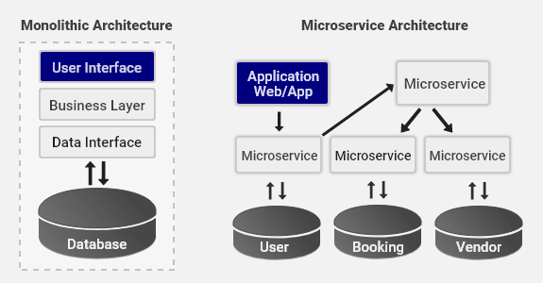

Micro service is a concept.

Spring cloud

Spring micro service

Spring people provide open source server which help to deploy n number micro service

Eureka Server :

First step we will create the Eureka Server

Create the project using spring initializr

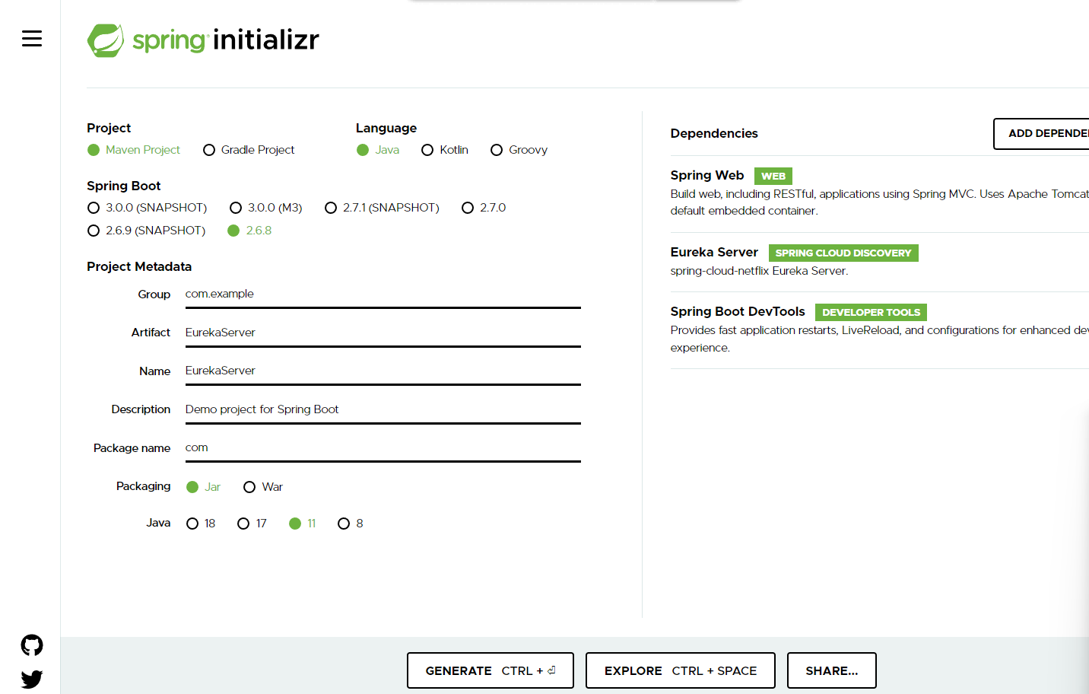

While creating Eureka Server project we have to add starter as

Web, devtool, and EurekaServer etc.

application.properties

server.port = 8761

eureka.client.registerWithEureka=false;

eureka.client.fetchRegistry=false

by default every web starter container tomcat web server and that server run on default port number 8080.

But by default all micro service project search eureka server on default port number ie 8761.

eureka.client.registerWithEureka when we make this option as false this project doesn’t register as a eureka or micro service client program.

In main class

@SpringBootApplication

@EnableEurekaServer

public class Demo {

public static void main(String args[]) {

SpringApplication.run(Demo.class,args);

System.out.println(“Eureka Server up!”);

}

}

http://localhost:8761

First Micro service project : FirstMicroServiceProject

Web starter

Dev starter

Eureka Client

application.properties

server.port =8181

Second Micro service project : SecondMicroServieProject

Web starter

Dev starter

Eureka Client

application.properties

server.port =8282

AccountService

WebStarter

DevStarter

EurekaClient

JdbcStarter

JpaStarter

Application.properties

Server.port = 8383

You have provide database

PaytmService

WebStarter

DevStarter

EurekaClient

Application.properties

server.port=8484